__________________________________________________________________________________

**Report**

**Expert Lecture on “Timeless Inspirator for Youth – Swami Vivekananda”.**

**Title**: Timeless Inspirator for Youth – Swami Vivekananda  
**Date**: 13th January 2025  
**Venue**: Room No. 109  
**Speaker**: Mr. Aditya Muske  
**Organizer**: Student Welfare Committee

An expert lecture on **"Timeless Inspirator for Youth – Swami Vivekananda"** was held on **13th January 2025** in **Room No. 109**. The session was conducted by **Mr. Aditya Muske** and organized under the **Student Welfare Committee**. The lecture focused on the remarkable life of Swami Vivekananda and his enduring message for the youth of today.

Mr. Muske provided an in-depth account of Swami Vivekananda's early life, his spiritual journey, and his significant contributions to society. He highlighted Swami Vivekananda’s teachings on self-confidence, hard work, and the importance of a strong moral character. The speaker underscored how these values can inspire today's youth to overcome challenges and achieve their goals.

The session emphasized the relevance of Swami Vivekananda’s message in modern times, encouraging students to cultivate qualities like discipline, resilience, and a service-oriented mindset. The lecture also shed light on Swami Vivekananda’s vision for youth empowerment, unity, and the pursuit of knowledge as the foundation for personal and societal progress.

The program was interactive, with participants engaging in meaningful discussions and drawing inspiration from anecdotes shared by the speaker. Students found the lecture both motivational and thought-provoking, leaving with a renewed sense of purpose and a deeper understanding of Swami Vivekananda's timeless ideals.

The event concluded successfully, reinforcing the significance of Swami Vivekananda's philosophy as a guiding force for the youth in shaping a better future.

Glimpse of Program:

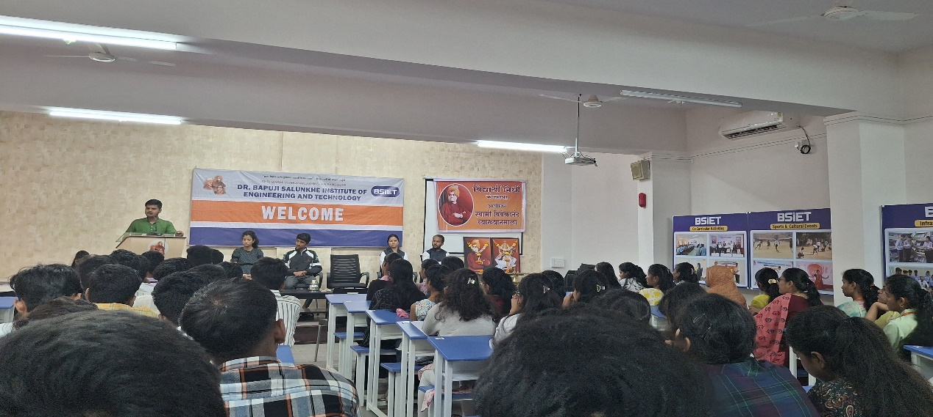

Guest Speaker Mr. Aditya Muske addressing the students

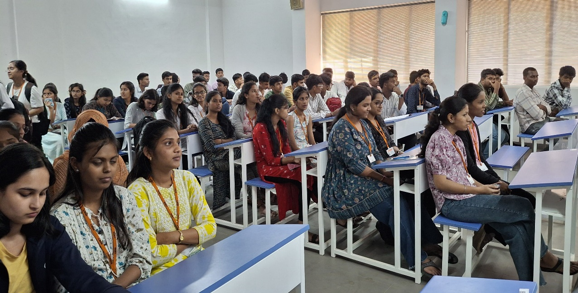

Mrs. S. M. Ingavale Dr. Suhas G. Sapate Prof. Viren D. Bhirdi

Event Co-ordinator Principal Director