 | ll ज्ञान, विज्ञान आणि सुसंस्कार यासाठी शिक्षण प्रसार ll- शिक्षणमहर्षी डॉ. बापूजी साळुंखे  श्री स्वामी विवेकानंद शिक्षण संस्था, कोल्हापूर संचलित  Dr. Bapuji Salunkhe Institute of Engineering & Technology  2130, Tarabai Park, Kolhapur – 416 003  Telephone: 0231-2658613, Web: www.bsiet.org

“To create awareness about Paper Bags Usage”

Event Date: 17/12/2024. Place: Central Bus Stand, Kolhapur.
The University Grants Commission (UGC) has taken a significance step towards reducing plastic wastes in Higher Education Institutions. According to the UGC guidelines, our institute Dr. Bapuji Salunkhe Institute of Engineering and Technology, Kolhapur has organized an activity to create awareness about paper bags usage instead of plastic bags under “Swachhata Hi Sewa Campaign”
- Context and Background:
Some key issues associated with plastic bags are:
- Non-Biodegradable Threat: Plastic bags persist in the environment for up to 1000 years, breaking down into micro plastics that continuously pollute ecosystems.
- Marine Life Endangerment: Millions of plastic bags end up in oceans each year, posing a deadly risk to marine creatures. Animals often mistake them for food, resulting in ingestion and enlargement.
- Ecosystem Contamination: Degraded plastic releases chemicals that seep into soil and water sources, disrupting ecosystems and contaminating drinking water.
- Climate Impact: The production and incineration of plastic bags emit greenhouse gases, contributing to climate change and global warming.

- Why Awareness about paper bags?
- Reduce Plastic Waste: The use of paper bags directly reduces the demand for plastic bags. Every paper bag used is one less plastic bag potentially polluting the environment. This shift can significantly decrease the volume of plastic waste generated.
- Lower Carbon Footprint: The production of paper bags, though energy-intensive, has a lower carbon footprint compared to plastic bags. This is due to the use of renewable resources(trees) and the possibility of recycling, which offsets the carbon emissions over the lifecycle of the bag.
- Reduce Toxicity: Paper bags, especially those made from unbleached or minimally processed paper, contain fewer toxic chemicals than plastic bags. This reduces the potential for harmful substances to leach into the environment during degradation.
- Energy Efficiency: While the production of paper bags requires energy, advancements in manufacturing processes have made it more energy-efficient. Many paper mills now use renewable energy sources, such as biomass, to power their operations, further reducing the environmental during degradation.
- Support for Sustainable Forestry: The demand for paper bags supports sustainable forestry practices. Many paper bags are made from trees grown in responsibly managed forests, where replanting and conservation efforts ensure a continuous supply of raw materials without depleting forests ecosystem.
- Improves soil fertility: When paper bags decompose, they contribute organic matter to the soil, improving its fertility. This contrasts with plastic, which offers no such benefit and can even degrade soil quality by introducing microplastics.
- Ecosystem Preservation: By choosing paper bags, we support a cleaner, more sustainable environment for all living organisms.

- Objective of the Activity:
- The primary objective of this activity is to raise awareness about plastic waste due to plastic bags and contribute to a cleaner environment.
- To promote sustainability by switching to eco-friendly alternatives like cloth bags or paper bags.
- Event Highlights: -
- Around 60 students made 300 paper bags from newspaper.
- About 110 students were actively participated in distribution of paper bags in the most crowded area, central Bus stand of Kolhapur to promote environmental consciousness.
- Summary –
  - The National service Scheme (NSS) unit of Dr. Bapuji Salunkhe Institute of Engineering and Technology organized a plastic bags awareness program on 17th December 2024, at central Bus stand, Kolhapur.
  - This is the most crowded area of Kolhapur. Paper bags are more environmentally friendly alternative to plastic bags because they are biodegradable, reusable and safer for food we took paper bags made from newspaper and distributed it in each shop, Hawkers, fruit and vegetable sellers and told them to prepare such bags and say no to plastic bags for healthier environment we educated people who were carrying plastic bags.
  - This activity aimed to raise awareness, change behaviour of people and to promote Sustainability.
- Program Outcomes
- PO6- The Engineer and the Society / World.
- PO7 Environment and Sustainable Development.
- PO8- Individual and Collaborative Teamwork.
- PO11- Life-Long Learning.
- Points Observed and Outcomes
- The Engineer and the Society / World: Students gain hands-on experience in environmental conservation, learning the importance of sustainability and the impact of pollution.
- Environment and Sustainable Development: Engaging in such drives fosters a sense of civic duty and encourages students to contribute positively to society and the environment.
- Individual and Collaborative Teamwork: Participating in a community activity enhances skills such as teamwork, leadership, and problem-solving, which are valuable in academic and personal growth.
- Life-Long Learning: -A cleanliness drive fosters life-long learning by encouraging individuals to continually adopt and apply sustainable practices, environmental awareness, and civic responsibility to maintain a clean and healthy environment.
- Upon the successful completion of the Paper bags usage awareness program, students will be able to
- Identify the environmental benefits of using paper bags over plastic bags.
- Understand the importance of reducing plastic waste and promoting sustainability.
- Recognize the role they can play in reducing their carbon footprint.
- Make informed choices about using ecofriendly alternatives for daily activities.
- Develop a sense of responsibility towards protecting the environment.
Event Coordinator | NSS Coordinator | Dean (Students Affairs) | Principal | Director
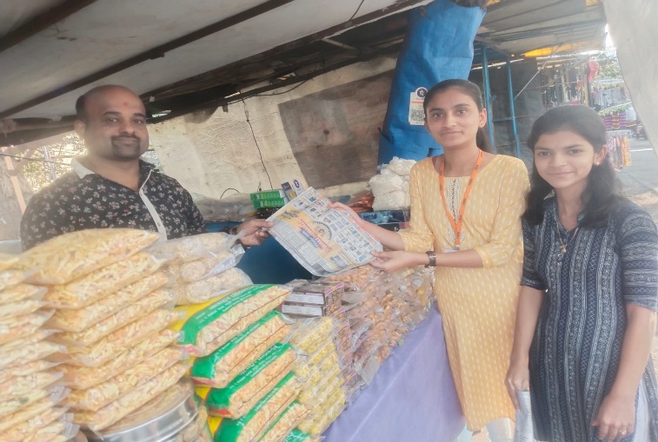 | 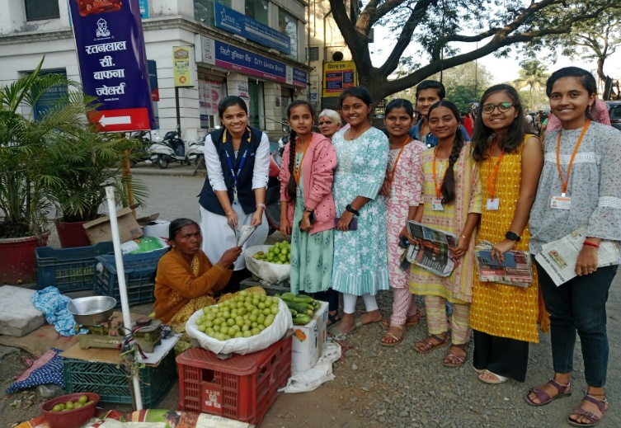
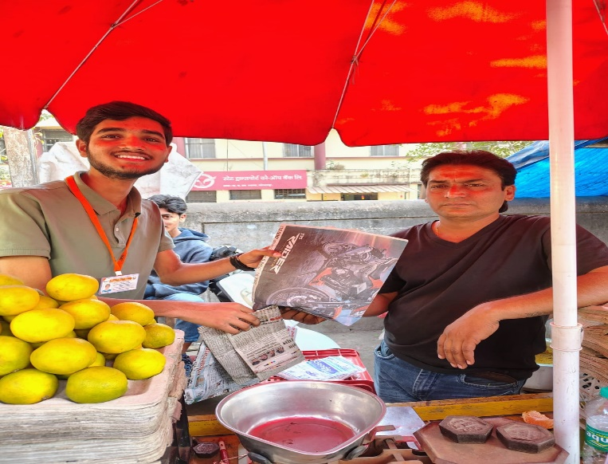 | 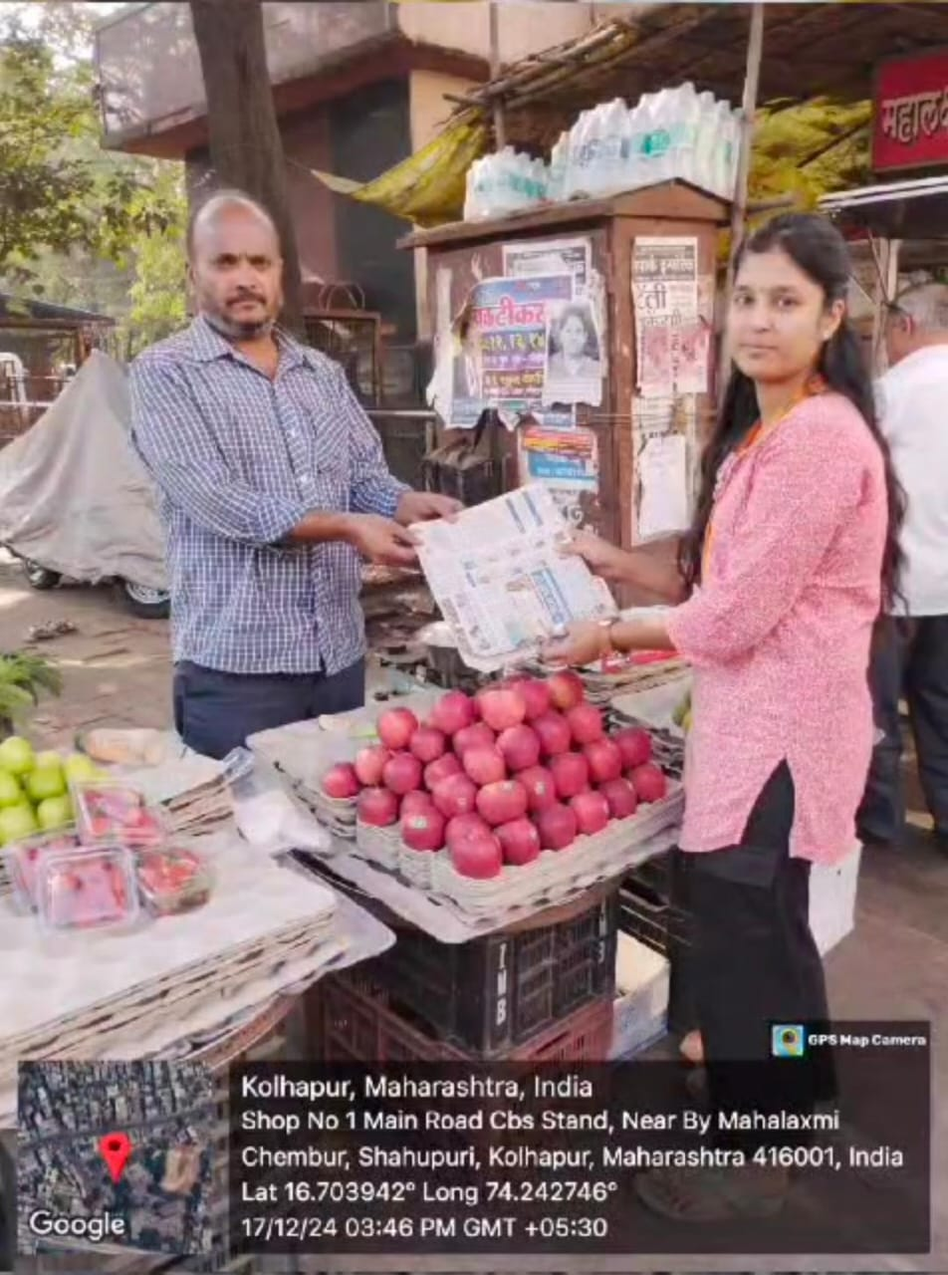
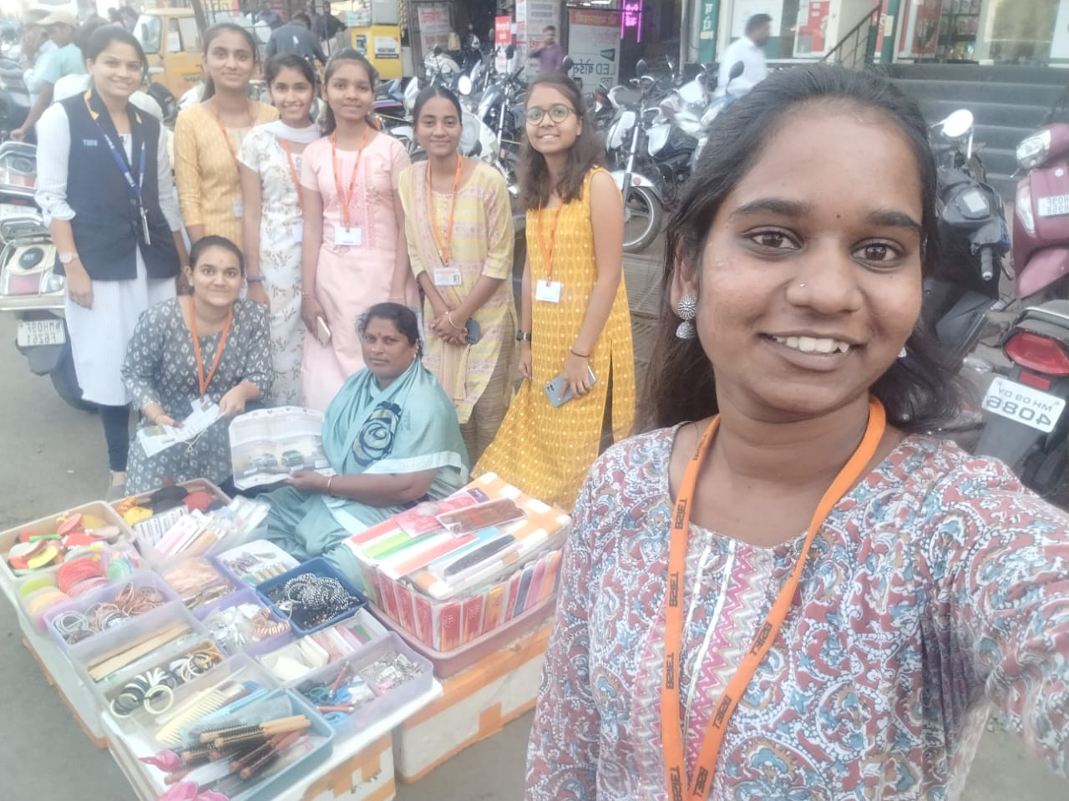 | 